Operation Manual

National Bamboo Database Web Portal (instructions revised on 12-04-2016)

1.1 Background
This interactive web portal is applicable for filling up the information on bamboo resource. Instructions are given below for operating and using this web portal. FDA / Division Level Officers are the smallest unit for collection of the data. States in which the bamboo is looked after by Horticulture Department / Officers and Bamboo Development Agencies a slightly modified strategy is followed for creating users for adding the information on bamboo resource.
The national bamboo resource database of the web portal so generated would be used through query based program by various stakeholders. The process of the same is now activated. The usefulness of which will be fully appreciated once the data entry in the web portal is complete.
The third aspect of the web portal is to enlist the important events regarding bamboo development publicity which may contain photo gallery, current and future events, downloads of important practices and documentaries on bamboo.
The web portal is managed and administered by Bamboo Technical Support Group – Indian Council of Forestry Research and Education (BTSG-ICFRE), Dehradun. This web portal has three levels of users i.e., the Administrator, State Mission Directors (SMDs) and FDAs (Division Level Users i.e., DFOs). In some of the states State Bamboo Mission is headed by Horticulture Department, Bamboo Development Agencies and Department of Industries and Commerce. Accordingly some minor changes are to be made while creating the users in consultation with State Mission Directors. The Instructions for State Mission Directors and Division Level Users (FDAs or Horticulture Officers or Block Development Agency) are given below. These instructions will help the users in operating this web portal. However for any difficulty BTSG-ICFRE / NABM may be contacted on phone, e-mail or through suggestion box provided in the web portal. The home page of web portal www.bambooindia.org is depicted in the snapshot below:
For best viewing and operation of web portal users are requested to use latest version of Mozilla Firefox or Chrome browsers

1.2 Step 1: Instruction (Help) for State Level Users – State Mission Directors (SMDs)/ Nodal officer at state level
State Mission Directors (including nodal officers) are responsible for the activities related to their state. The tasks to be performed by them are also related to their state only. For this, visit the home page of the web portal which appears as seen below. Few tabs appear on the home page of web portal which are self explanatory. Take few seconds to toggle through the tabs. The address of the administrator is given in the home page which can be used if need arises. SMDs are the very important pillars for the management of web portal at the state level. All the divisional level officers of the State are connected through him to the web portal. The SMD level users are created by the administrator and are provided with the first time user's password. The SMDs can login through login tab in the home page.
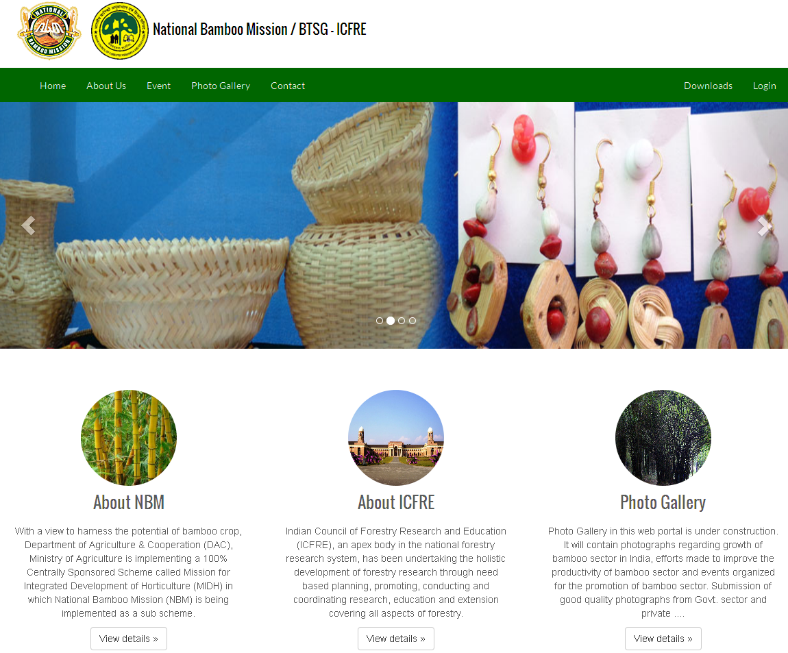
1.2.1 The responsibilities of the SMDs / Nodal officers are:
- Adding the list of the 'Forest Divisions' of the state to the web portal
- Creating Forest Division Level Users (DLUs) and providing first time username and password (one user in each division)
- Editing the profile of Division Level Users on their transfer
- Ensuring the entry of data by the Division Level Users
- Approval of the data entered by division level officer and submitting the data to administrator for final approval
- Adding the list of 'Forest Circles' of the state to the web portal for use in query generation
- Adding the list of 'State landscape' of the state to the web portal for use in query generation. This function gives the opportunity to design the area / landscape according to the requirements of state and obtain the targeted query from the database. The State landscape is specific to a particular state and cannot be used for query generation of other states
- Over all supervision of the data entered by Division Level Officers of the state
Sequences of steps to be followed by him (SMD) are as under:
- SMDs are provided with username and password for first login by administrator.
- SMDs can sign in through state level users by selecting their respective 'state' from drop down menu as username and given password.
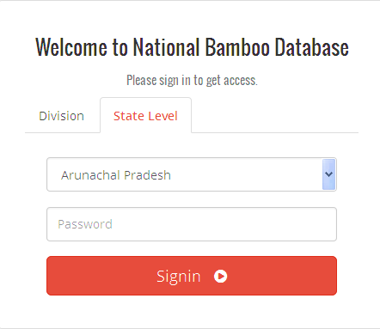
After login a new window appears as shown in the next page. Take sufficient time to toggle through the tabs on the dashboard page. Ten tabs starting from extreme left namely Dashboard, Masters to Data Analysis on extreme left appears on the page. Function of each tab is described below:
- Dashboard: When this tab is highlighted
- It gives information about the number of users in the web portal (including administrators, SMDs / nodal officers and Division Level Users) that have been created.
- Number of forest circles that have been added to the web portal by SMDs / nodal officers
- Number of State Landscapes created by SMDs / nodal officers in the web portal
- Number of National Landscapes added to the web portal by Administrator
- Number of forest divisions that have been added to the web portal by SMDs / nodal officers
- Number of bamboo species with which this web portal deals
- Number of input formats that have been created by Division Level Users
- Any instructions that will be required to be passed on to the users
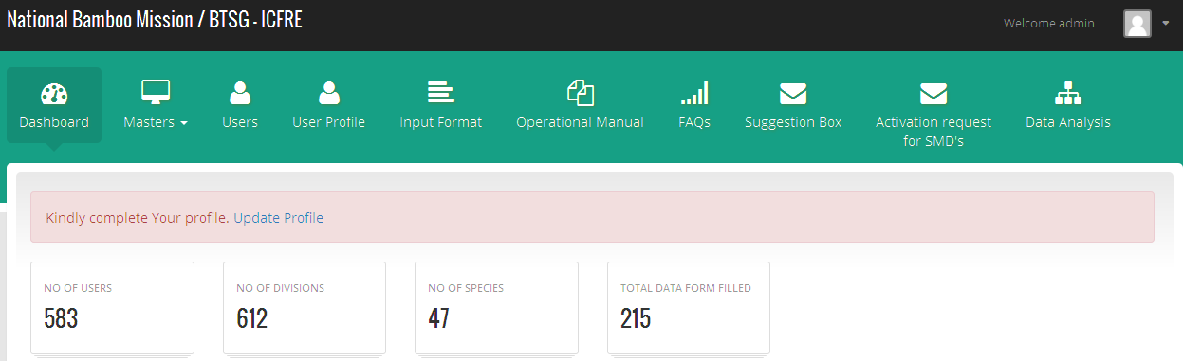
- Masters: When the cursor is placed on this tab a drop down menu appears. This tab is mainly created to help Administrator and SMDs and hence may not be visible to Division Level Users. The main content of this tab are:
  - It contains the list of drop down menus that have been created by administrator and SMDs for use by Division Level Users while filling the data input formats and also used for query generations
  - It contains drop down menu of States, National Landscapes, Districts, species, funding scheme names, type of area, and type of nurseries, gregarious flowering, treatments, and source of information. These lists have been prepared by Administrator / developers for use by Division Level Users and will be available while filling the data input formats
  - Some drop down menus are created by SMDs / Nodal officers such as list of Forest Divisions, State landscapes, Forest Circles
- Users: This tab is used for creation of users by SMDs and administrator. It also shows the lists of the users at national level (visible to administrator), state level (visible to SMDs) and Division (specific to division – only one users)
- Users Profile: This tab is given for editing the profile by users in case of need
- Input format: This is the tab for opening the input format for data entry by Division Level Users. However the same is visible to administrator and SMDs for monitoring the progress
- Operational Manual: It gives the necessary instructions for operating this web portal
- FAQs: This tab has been created for answering the frequently asked questions by the users
- Suggestion box: SMDs and Division Level Users can submit suggestion through this box to the administrator regarding the web portal. This can be used for posing in any problem faced by users to the administrator. Your suggestions will automatically go to the e-mail of administrator and will be available to him through web portal also. The administrator will address the suggestion and post it on the web portal which can be seen by the users
- Activation request for SMDs: This tab is exclusively created for SMD and will not be visible to Division Level Users. This tab will be used by SMDs exclusively for submitting request for approval of data of particular division for entering the data into the permanent database of the web portal. The division level user will then be activated for submitting the data for permanent record of the web portal. The procedure of this explained in detail later on
- Data analysis: This tab contains the structured query based programs for extracting data from database of web portal. Numbers of queries have been developed for use by users. At present the queries are available only to administrator, SMDs and Division Level Users. These queries are based on real time data that is being filled by Division Level Users. However these queries will be applicable on permanent records once the data has been approved at different level through a set of procedures and transferred to permanent record.
Depending on the level of users these tabs may vary in number. Particularly the tab 'Masters' and 'Activation request for SMDs' will not be visible to Division Level Users. The page also gives detailed information about users in the web portal, forest divisions added, number of species for which data is to be filled and number of input formats that are being filled by Division Level Users.
- Create Divisions: After login into Bamboo Database Web Portal SMDs are to click on Masters > Division> Add New". This process will complete the addition of divisions of the respective state. The updating of divisions is also possible at later stage also but before creating the Division Level Users the particular Division is to be added to the list.
- After first login SMDs may change their password for security reasons by clicking on tab 'User Profile'. A new window will open where the profile can be updated. SMDs may fill the division where their office is situated from the drop down menu (this list will display those divisions that have been added by SMDs, they may choose the division from the list displayed)
- Create Division Level User: After the divisions are added, the Division Level Users can be created by SMDs. The mandate of the Division Level Users is to enter the data of bamboo in the database for their respective division by going to tab "Input Formats". No data can be entered by SMDs at his level or from his ID. SMD's will create the Division Level Users by filling complete unique information regarding division level user. The Division Level Users will be activated by Web Portal Administrator after which the account (user ID) will be active for login
- For creating Division Level Users, kindly follow the following steps: User > Add New User > Select Division and fill complete form and submit. Information of approval and creation of division level user will be sent by SMDs to user subsequently. The activation can also be viewed by SMDs after which the division level user will be able to login.
- While creating division level user all information of the division user is to be filled. The e-mail and phone number etc., should be unique and not repeated for other users. Username, password, e-mail are mandatory fields. Only one user for each division can be created. Multiple users for one division will not be allowed by the administrator and will be blocked if created. In case the Division Level User is transferred or the username or password is forgotten, the same can be edited / reset by SMDs
- Division level user information submitted by SMDs will be verified and checked by web portal developer before granting approval. The account will be activated after the approval is granted
- SMD may update his username, password, phone numbers, email address as soon as he enters the 'User profile' link. The SMD may be blocked, if he does not complete his user profile. This is also important for the security of database.
- SMDs can go to different tabs provided and can familiarize himself about the portal / database
- SMD will be able to see all the information pertaining to his state, entered by Division Level Users
- SMDs will be able to see the list of Division Level Users he has created for his state
- For the States where bamboo related activities are handled by Horticulture Department and Bamboo Development Agencies, the users are to be created in consultation with BTSG-ICFRE. The contact information of BTSG-ICFRE is given on the home page of web portal and is also reproduced here:
Assistant Director General (Research Planning), Directorate of Research,
Indian Council of Forestry Research & education (ICFRE), Dehradun-248006
E-mail: adg_rp@icfre.org, kothiyalv@icfre.org
Phone: 0135-2753290; 0135-2224807
- Instructions for SMDs for creating Division Level Users is as detailed below:
    - Before creating 'Division users' SMDs will require adding Division by going on tab 'add division'. By clicking here a new window will appear where divisions can be added by pressing 'add new' tab. This process can be repeated for entering more divisions. One can add divisions later on also as and when required. This list can be edited/ modified if required by SMDs
    - Now SMDs can click on 'user' tab given at the top – a window will appear -- by pressing 'add new' button a new window will appear again requiring SMDs to fill the required information of the division level 'user'. Kindly ensure that e-mail addresses and phone numbers are correct, as the same may be used for future correspondence. SMDs can also see the status by logging on to the web portal.
- Instruction for SMDs for creating 'Forest Circles' and 'Forest landscape'
  - Forest Circles are the important administrative unit of the forest department and may like to extract the information on bamboo resource on the Circle basis. This data base however stores the information in the form of forest division, district and state. For extracting the information on forest circle basis structured query program are to be designed. For this 'Forest Circles' are to be created in the web portal. SMDs have the responsibility for adding the forest circles to the web portal master record. The same will be used during query generation
  - Many a time the information may be required to be generated in form of 'Forest landscapes'. These are not the administrative unit in the states, but the different forms of landscapes that may exist within a state e.g. Forest types, hilly area or the plains of the state and so on. Also a tailor made query may be required by combing few district or divisions. These state landscapes are to be defined by SMDs and added to the web portal master record. The same will be used during query generation.
  - For adding Forest Circles kindly follow the following steps: Masters > Forest Circles > State > Add New > Circle name > State > Click Divisions or Districts and submit. Selection of Division or District is kept optional due to over lapping nature of forest divisions and districts. If alone forest division is selected then that portion of the district which falls in the particular division will be used for query. Similarly if alone district is selected then only that portion of the division will be used for query which falls in the particular district. Selection can alone be made on the basis of divisions or district. This flexibility has been included depending on the requirement of different states.
  - For adding Forest landscapes kindly follow the following steps: Masters > State landscape > State > Add New > Landscape name > State > Click Divisions or districts and submit. Selection of Division or District is kept optional due to over lapping nature of forest divisions and districts and has been explained in point number 3 above. SMDs can also create tailor made landscapes based on the state's requirements which will be specific to states. For landscapes which are similar to the terminology used at national level, the states should follow national level definition as these will also be used for creating 'National landscape'. Any error or mistake in this will be reflected at national level also. Examples of such national level landscape may be as: Forest types of India; West Ghats, Eastern Ghats, Costal Areas, North-Eastern States, Himalayan belt etc.
  - Creation of National landscape will be done by Administrator i.e., BTSG-ICFRE. The same can be used by all users for query generation

1.3 Step 2: Instruction (Help) for Division Level Users (Division Level Officers)
Division Level Users are responsible for the activities related to their forest division. The tasks to be performed by them are also related to their state only. For this visit the home page of the web portal www.bambooindia.org which appear as shown in the instructions for SMDs. Few tabs appear on the home page of web portal which are self explanatory. Take few seconds to toggle through the tabs. The address of the administrator is given in the home page which can be used if need arises. Division Level Users are very important unit for compilation of the information on bamboo resource and filling the data related to their division in the input format. All the divisional level officers of the State are connected to the web portal through SMD or nodal officers. The SMD creates the Division Level Users and provides the first time user's password to Division Level Officers. The Division Level Officers can login through login tab in the home page as shown in the snapshot below. The responsibilities of the Division Level Users are:
- Filling the data in the input format
- Ensuring the correctness of the data
- Submitting the data for approval to SMD
- Management of the data at division level
- Over all in charge of the data at division level

Steps to be followed:
- Division Level Users will be provided with the username and password by SMDs for the first time login. They may change password after first login by update profile link

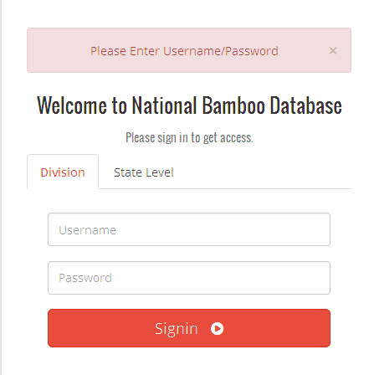

- Kindly familiarize yourself with different tabs given on the web portal as illustrated for instruction to SMDs. Operating instructions are provided in 'Operational Manual' tab. kindly read it before filling the data.
- Data entry in the input formats is the main responsibility of Division Level Users. For this after login into Bamboo Database Portal click on Input Formats Link > Add New "A data entry form will open". Familiarize yourself with the form and start entering the data of your Division collected from the field. The data input format consists of nine steps (one basic information + eight forms from sl. no 1 to 8) as seen in the snapshot below. You can toggle through different steps before filling the input formats. This database is not limited to NBM scheme, so all the data with regards to other schemes also is to be filled.

